To supply left over food to poor

COLLEGE NAME: CHIKKANA GOVT ARTS COLLEGE, TIRUPUR.

COLLEGE CODE: asbru06

TEAM ID: NM2025TMID26272

* TEAM MEMBERS:

TEAM LEADER NAME: MANOJKUMAR.M

[EMAIL :manojkumar883840@gmail.com](mailto:manojkumar883840@gmail.com)

TEAM MEMBER 1: LOGESH.P

EMAIL: [logeshuniverse3@gmail.com](mailto:logeshuniverse3@gmail.com)

TEAM MEMBER 2: SIVARAMAKRISHNAN.A

EMAIL: [siva2006kid@gmail.con](mailto:siva2006kid@gmail.con)

TEAM MEMBER3: PRASANTH.A

EMAIL : [tamilarasan2337@gmail.com](mailto:tamilarasan2337@gmail.com)

# INTRODUCTION:

1.1 PROJECT OVERVIEW : Our project focuses on connecting surplus/leftover food from hotels, functions, and

households to needy people.

Food

collection

Awareness

& impact

quality &

safety check

To supply left

over food to poor

Tracking &

documenta

tion

Packaging&

storage

Distributio

n &

logistics

# DEVELOPMENT PHASE

CREATING DEVELOPMENT ACCOUNT :

By using this URL – <https://developer.salesforce.com/signup>

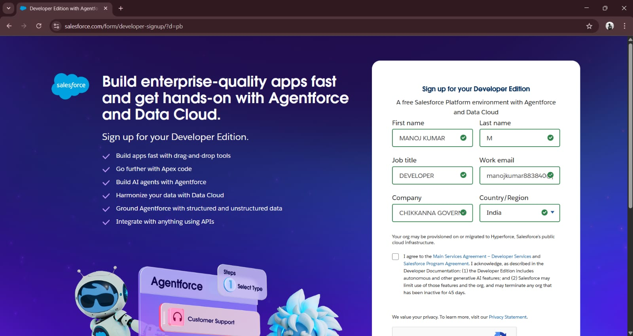

* Created objects : venue , drop of point ,task , volunteer , execution detail

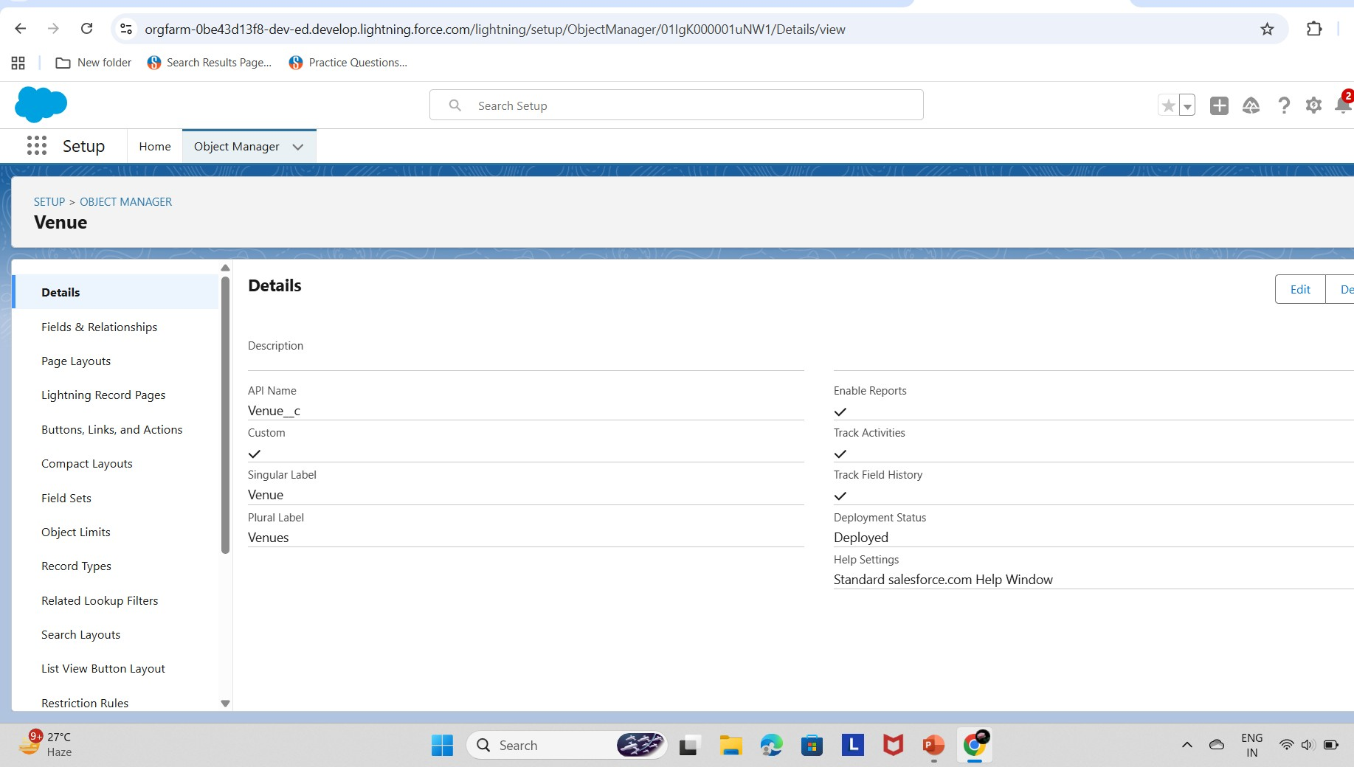

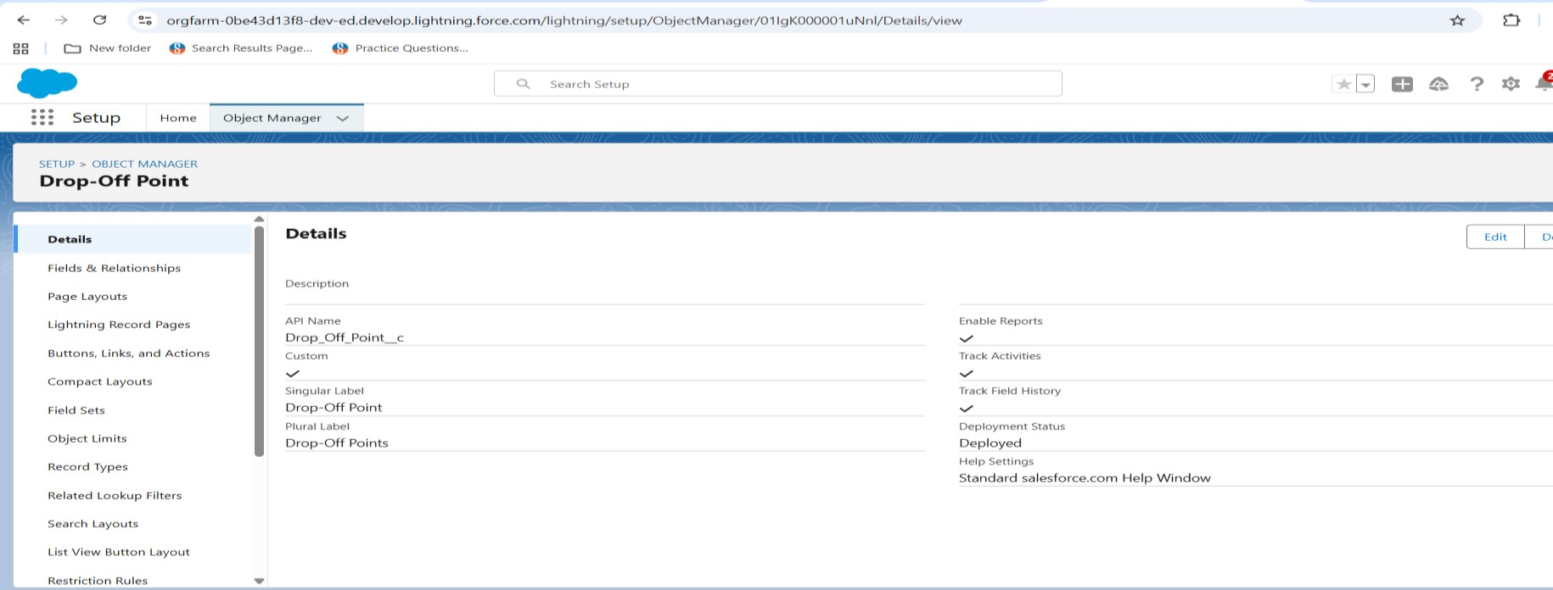

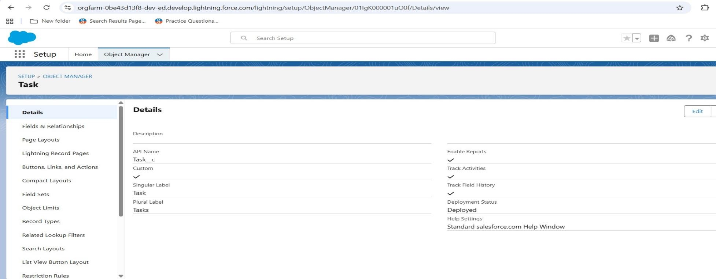

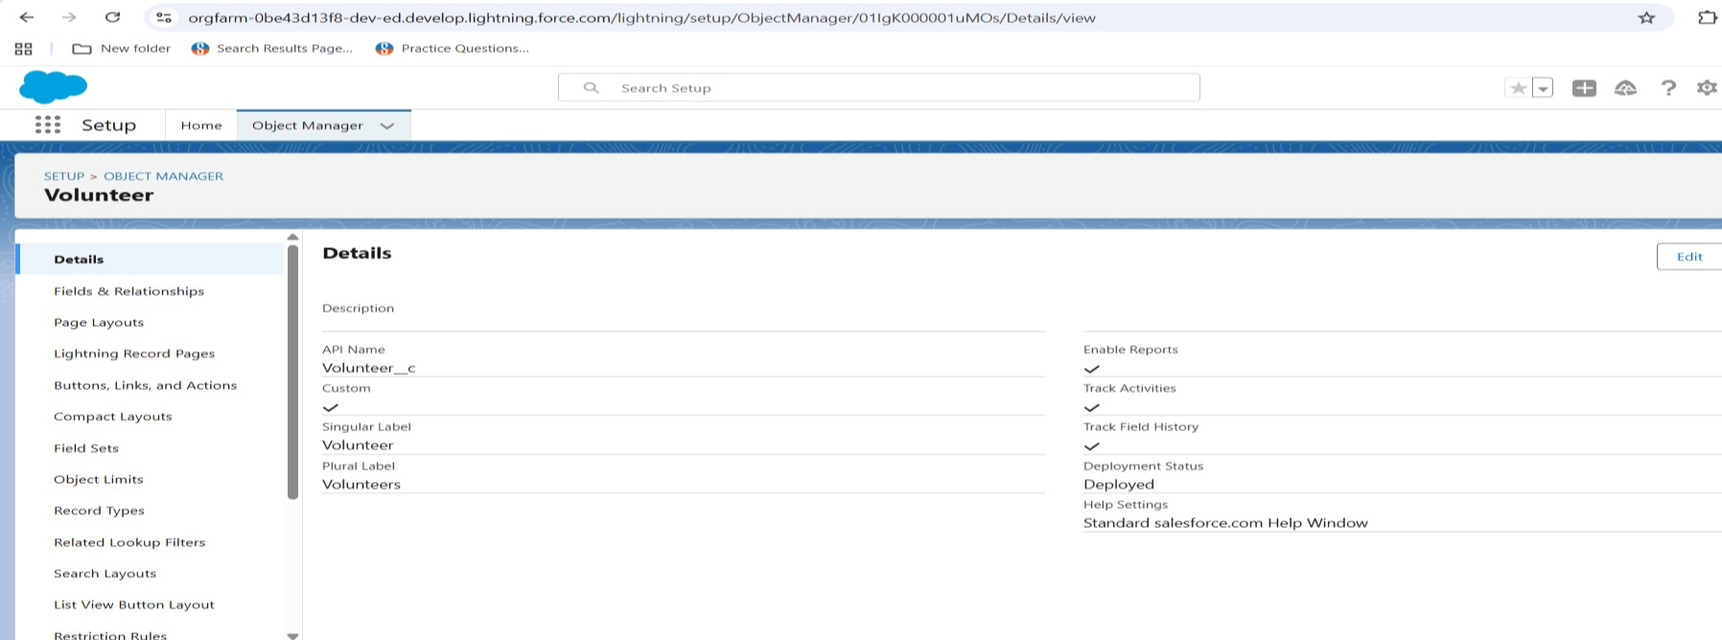

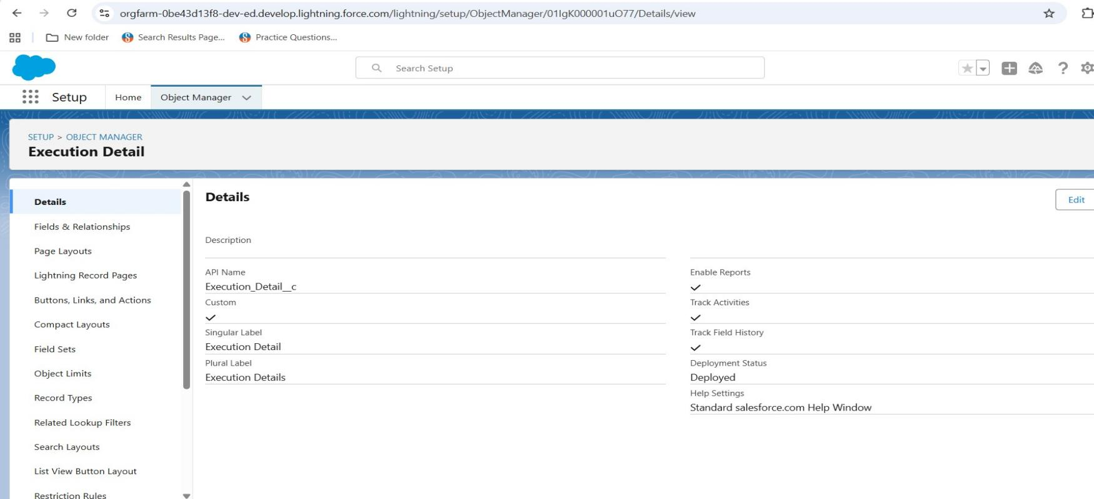

* + Configure fields and relationship :

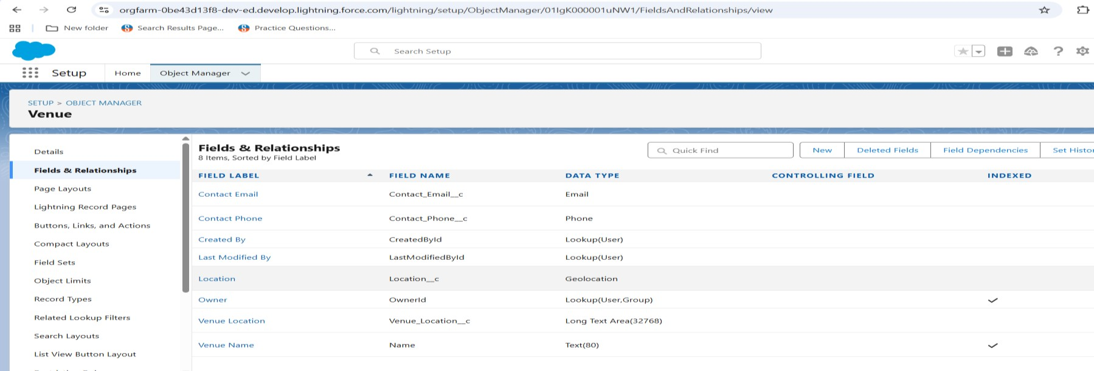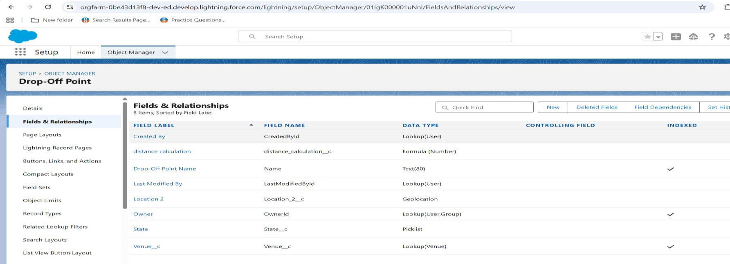

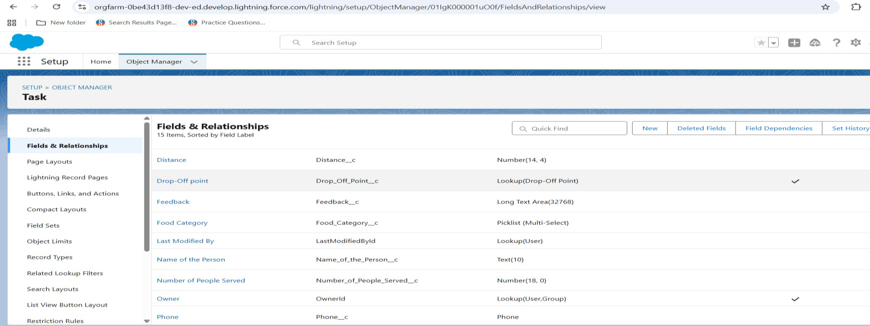

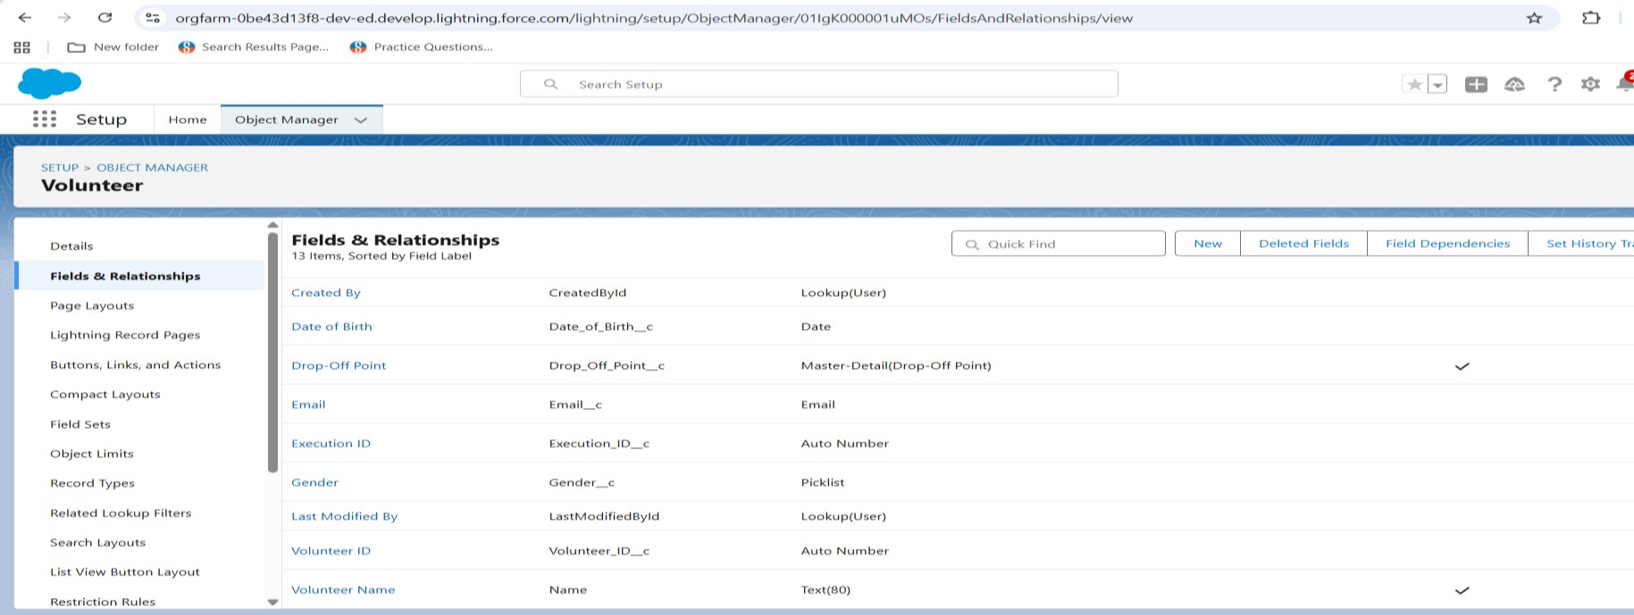

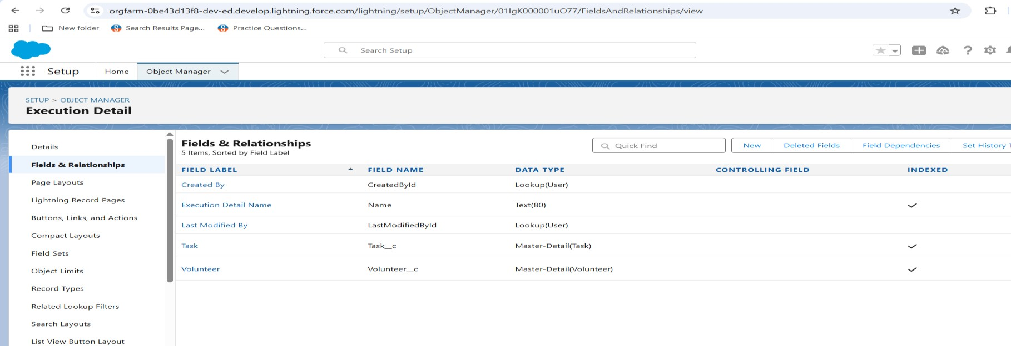

* + - Development Lightning App with relevant tabs :

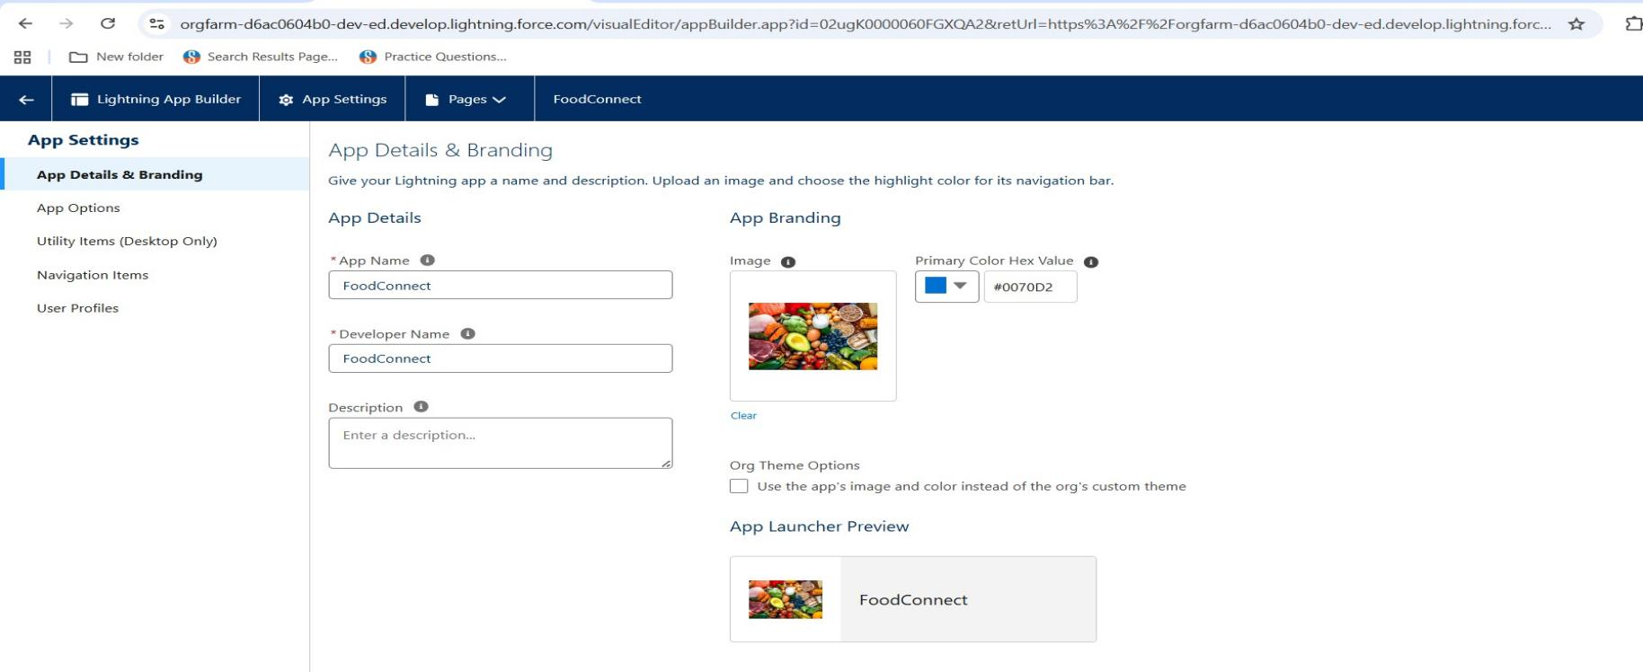

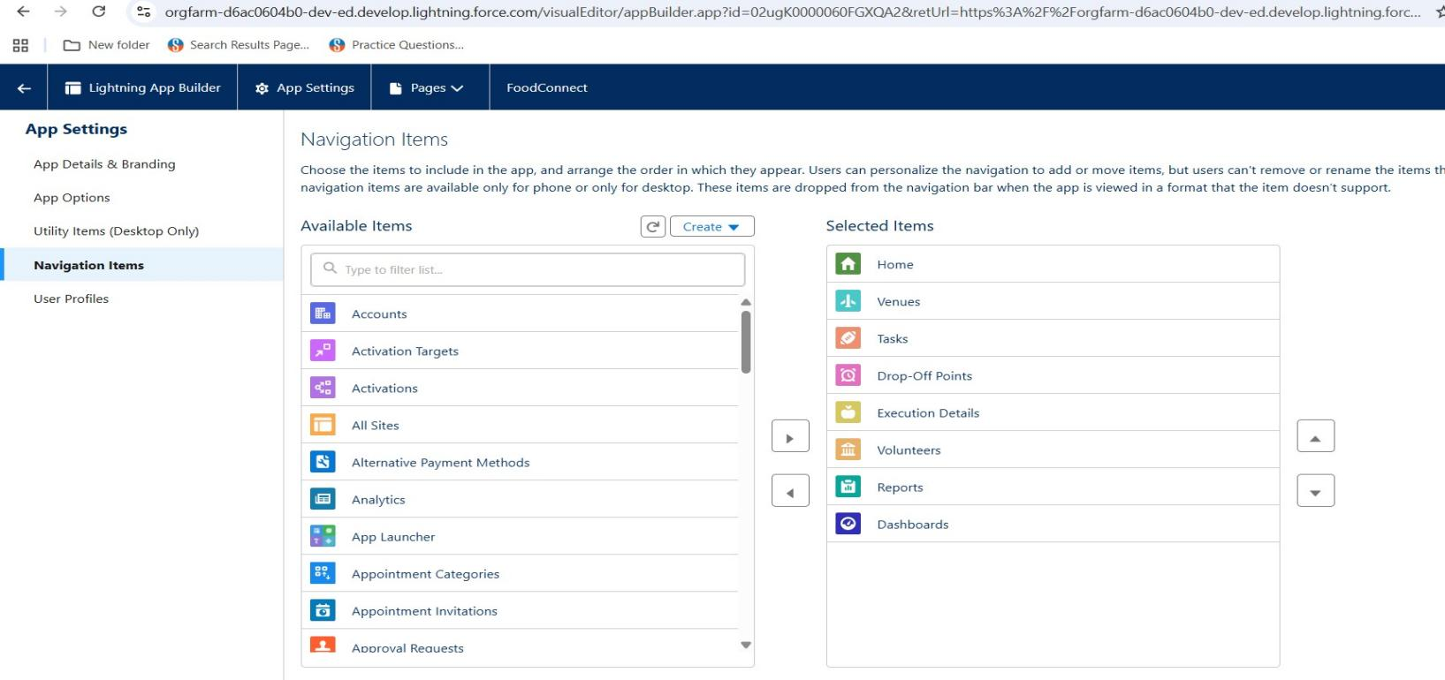

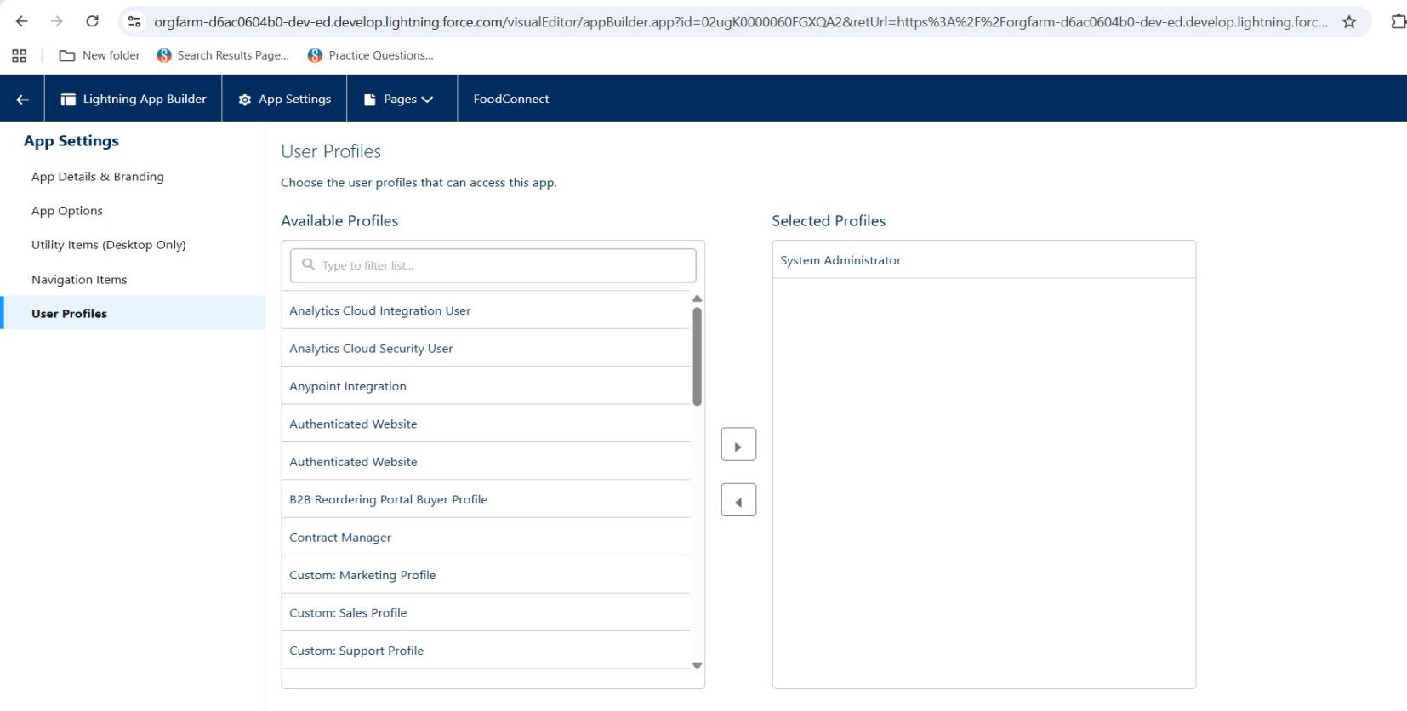

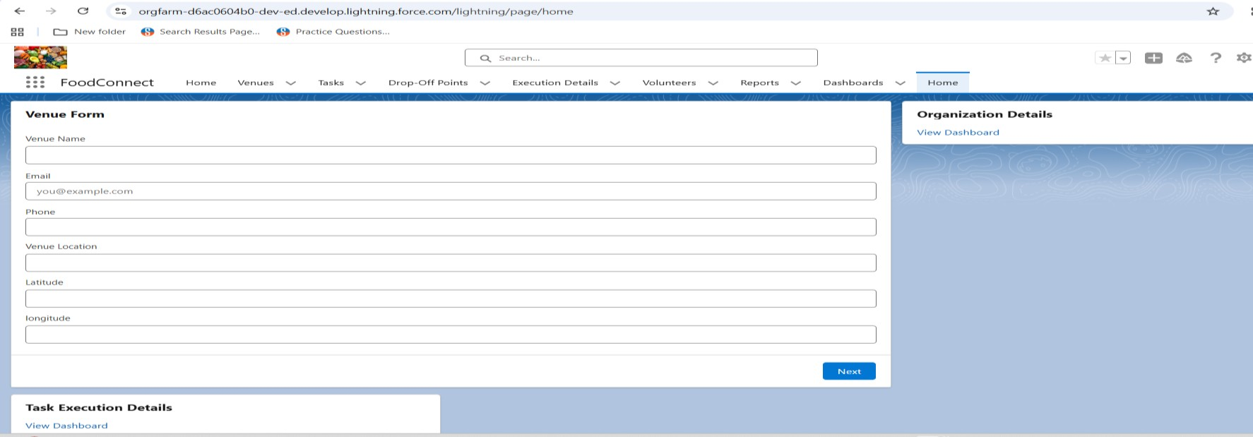

* + - 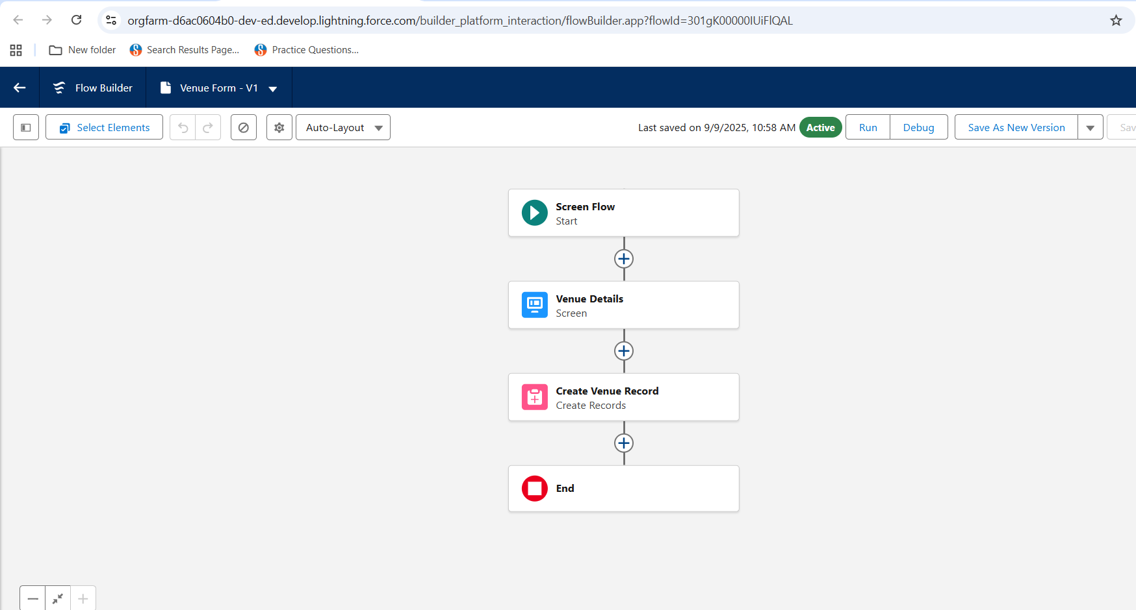Implement flows for venue details and create venue record :
    - To create a fields for the drop of point :

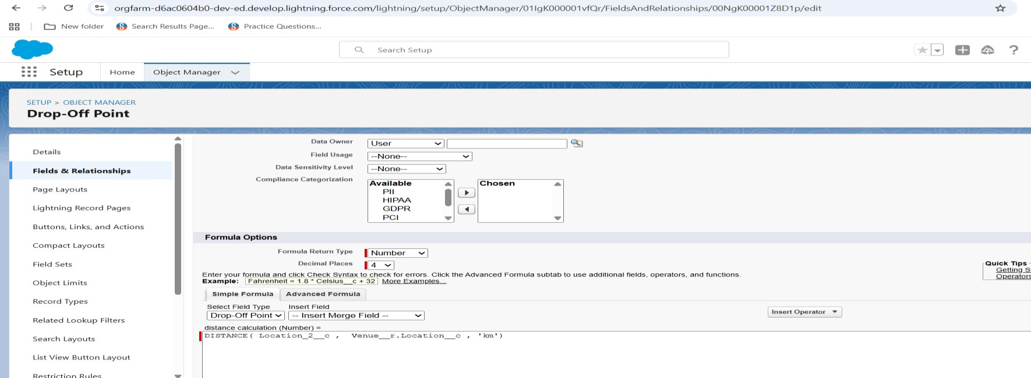

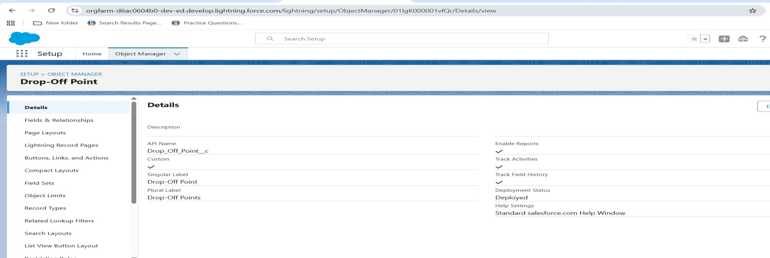

* + - 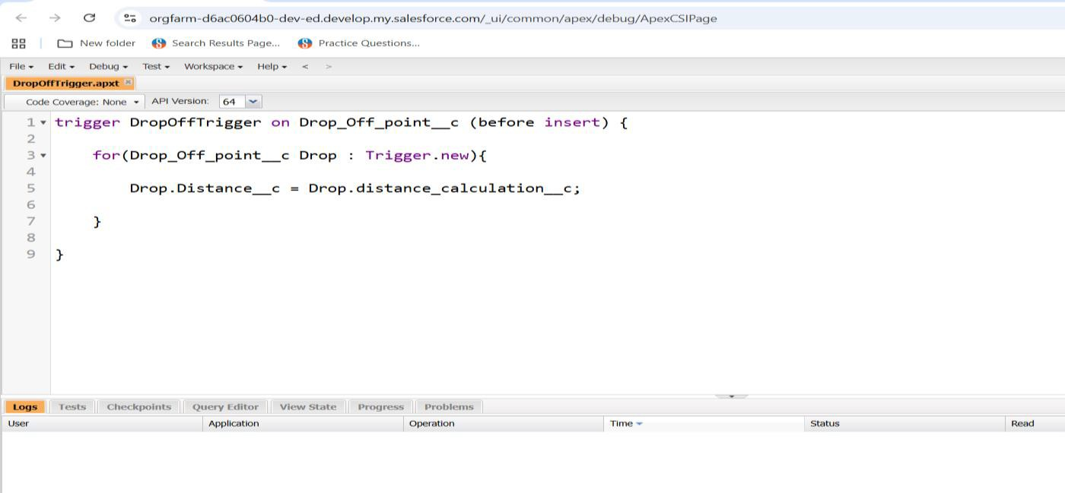Added apex trigger for coding :

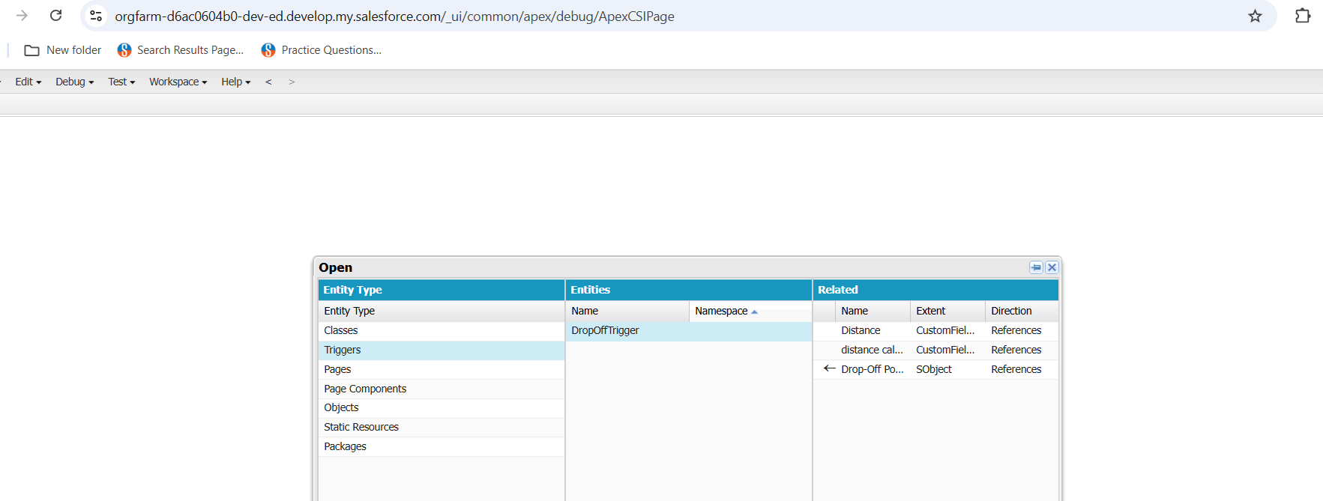

* + - 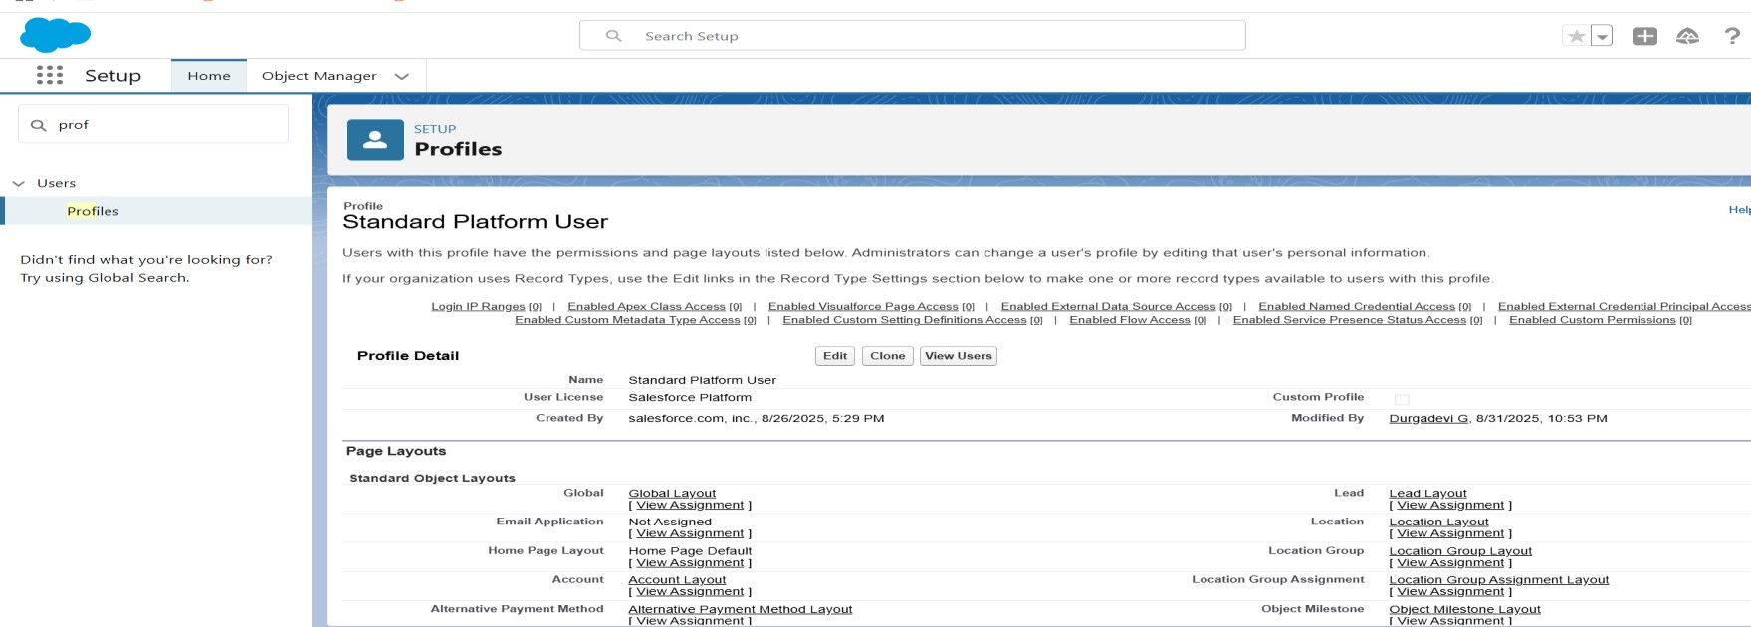Create the profile for standard platform user :
      * User 1 creation :

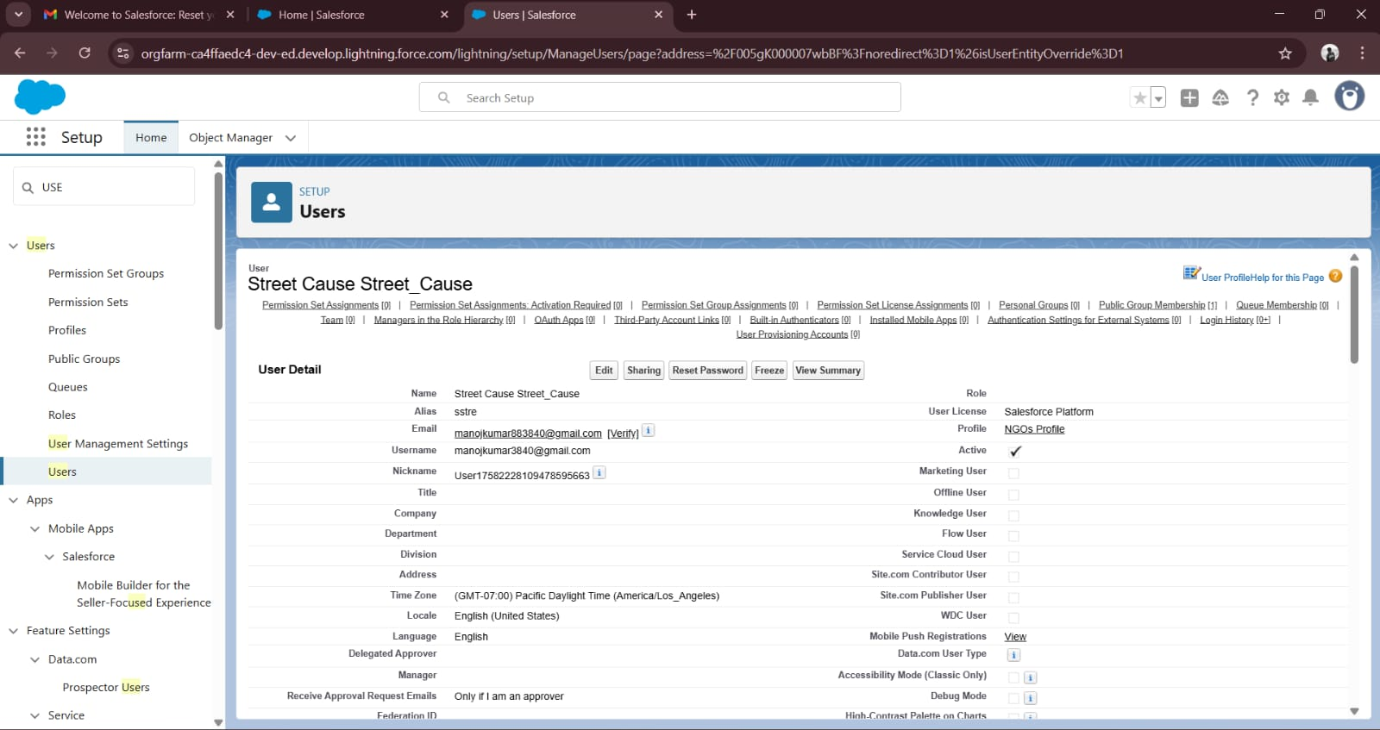

* + User 2&3 creation :

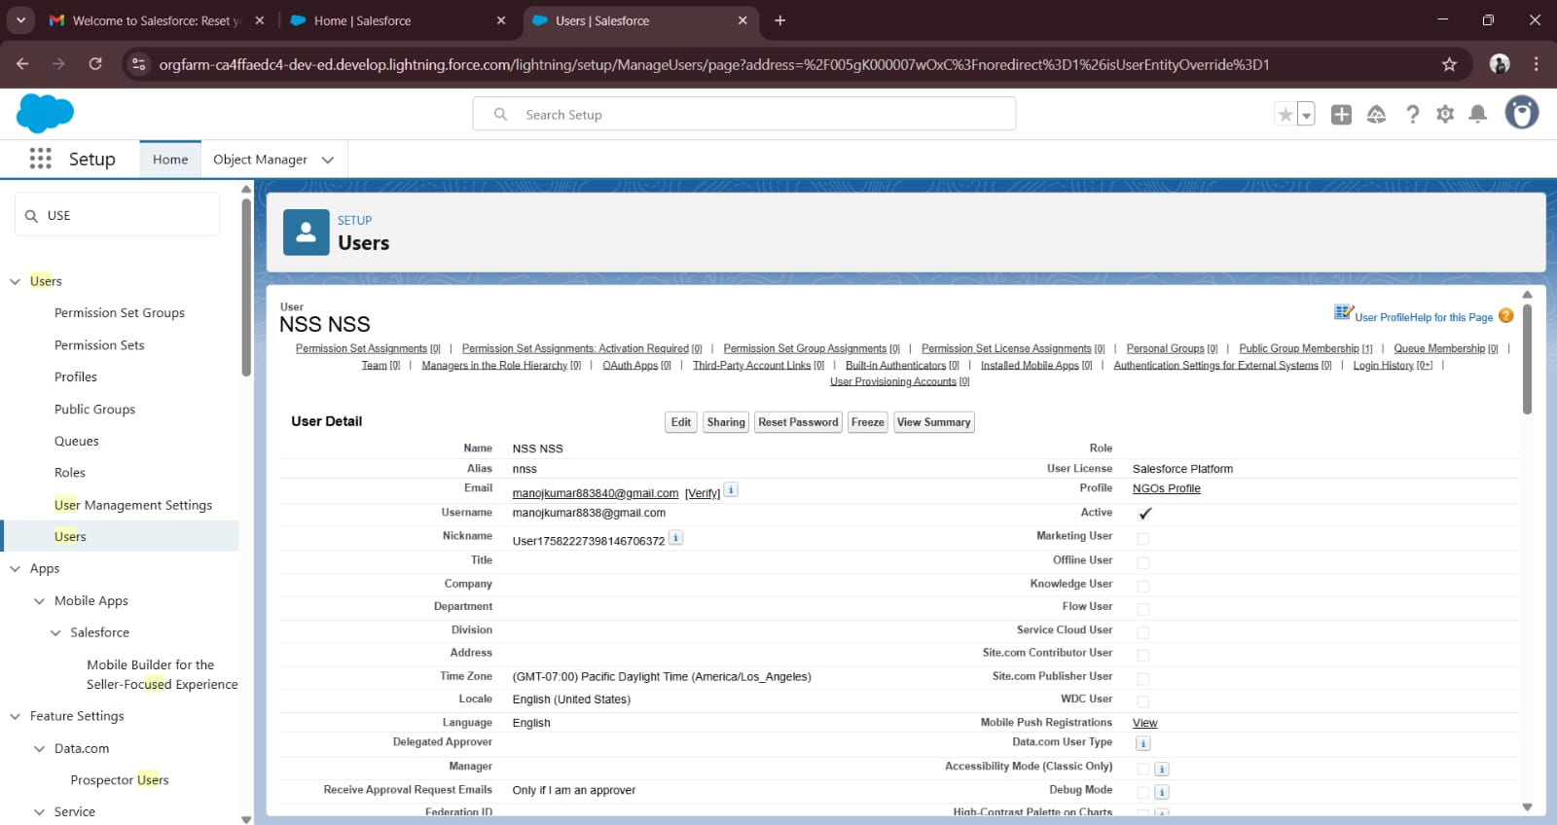

* + Create the report type :

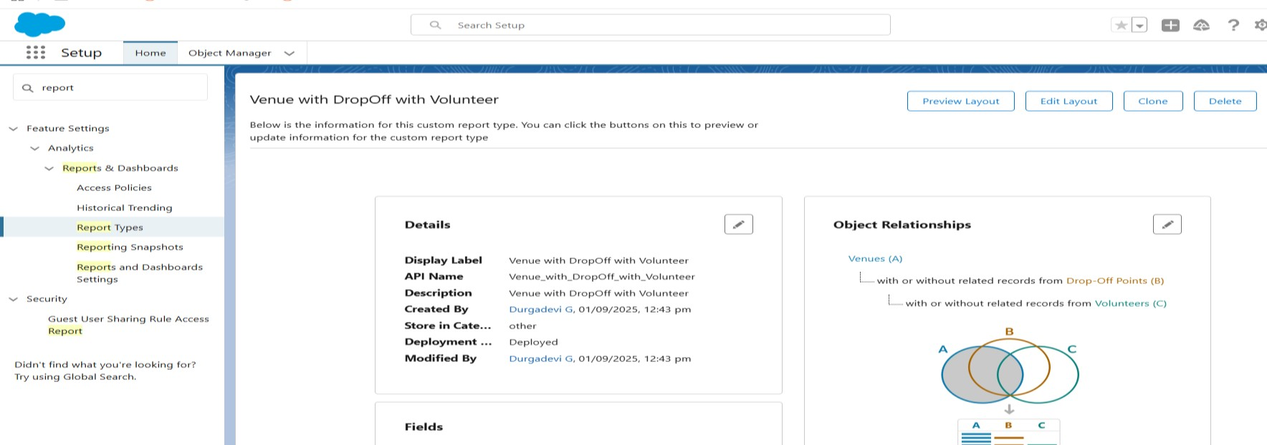

* Creation of report on : venue with drop of with volunteer , execution details and task

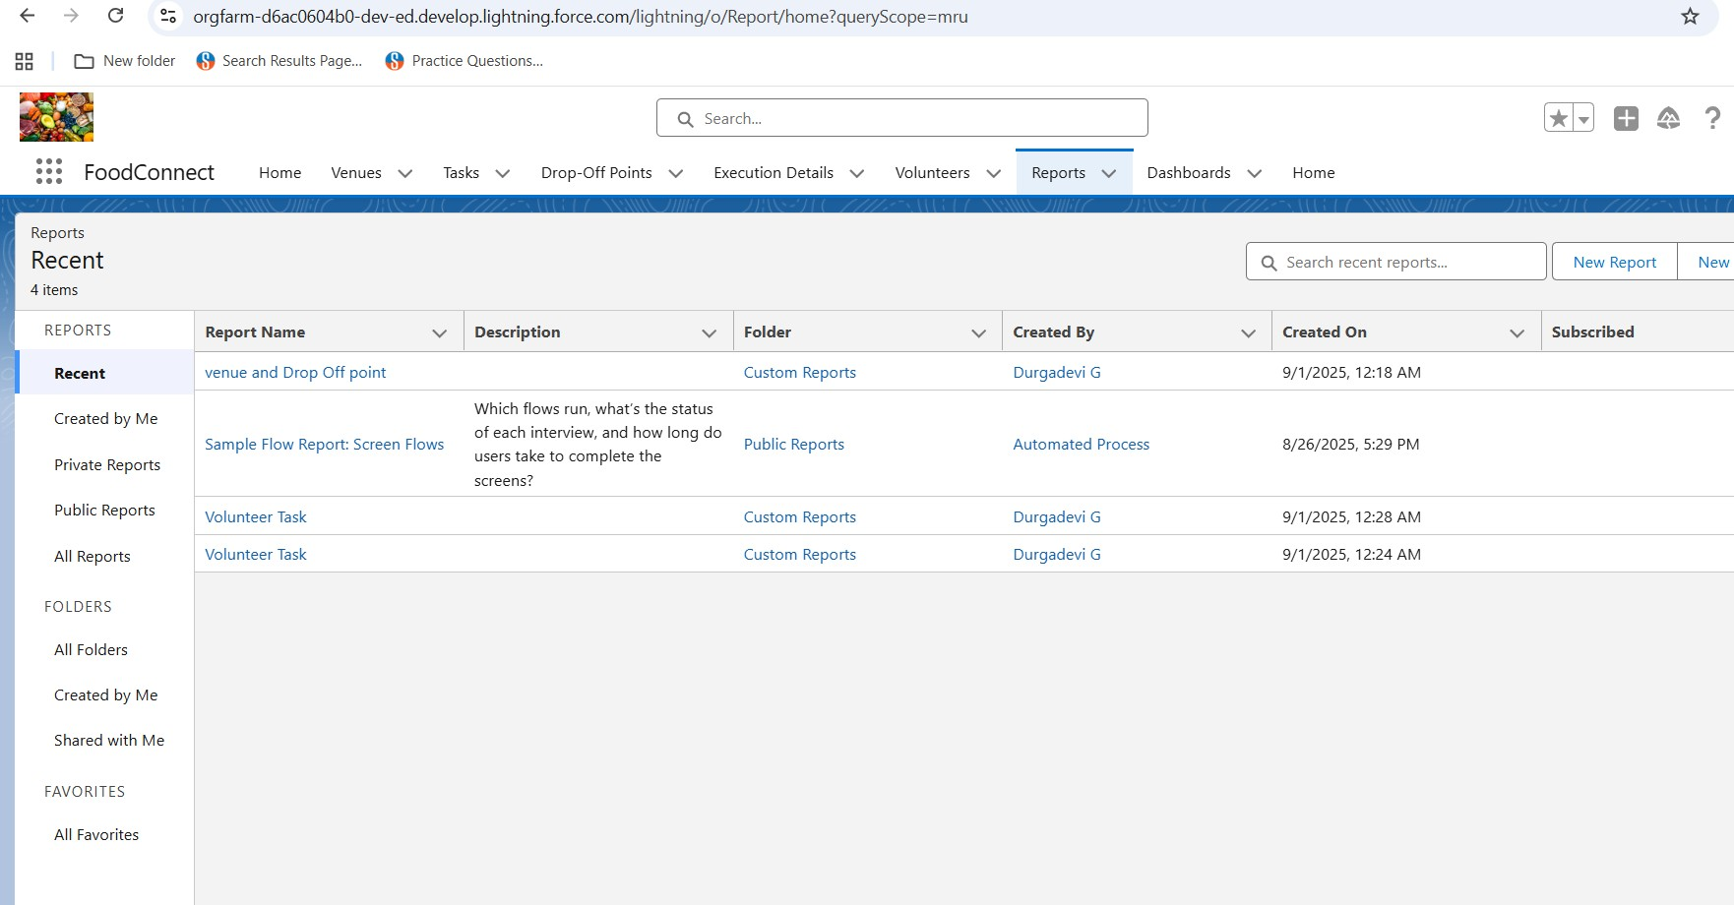

* + Dashboard adding for : venue and drop of point ,volunteer task & A picture to the

dashboards

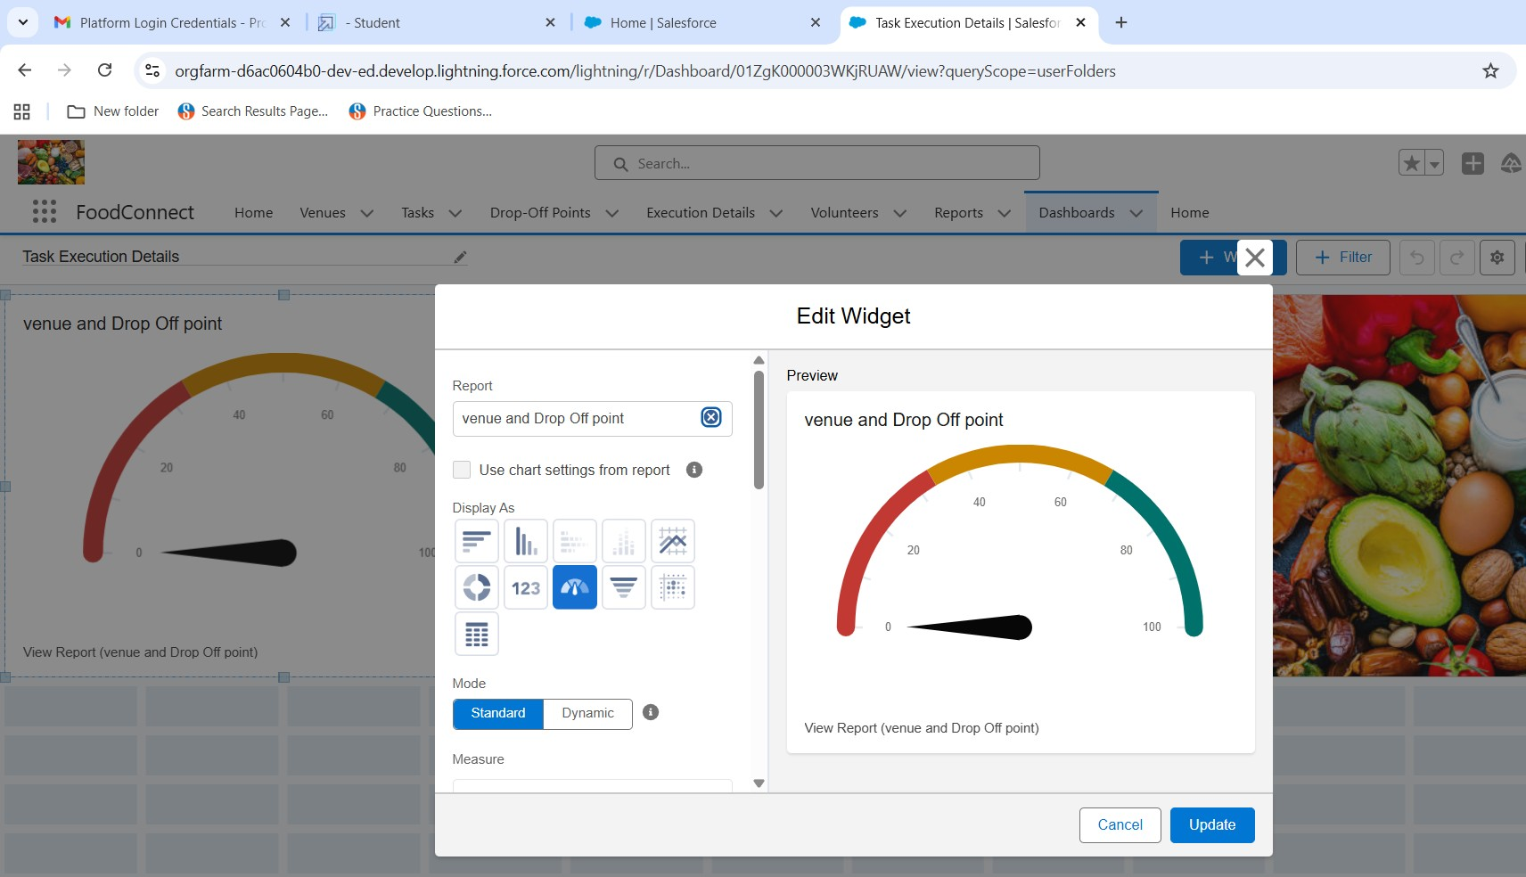

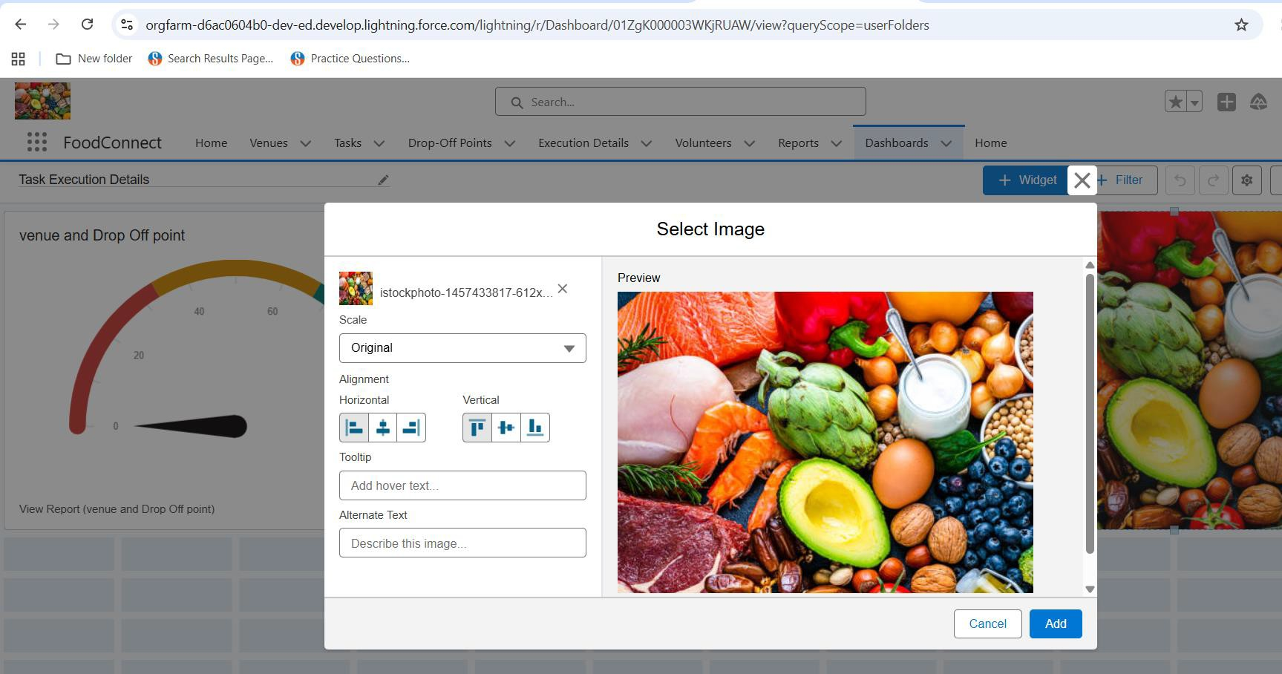

* + - 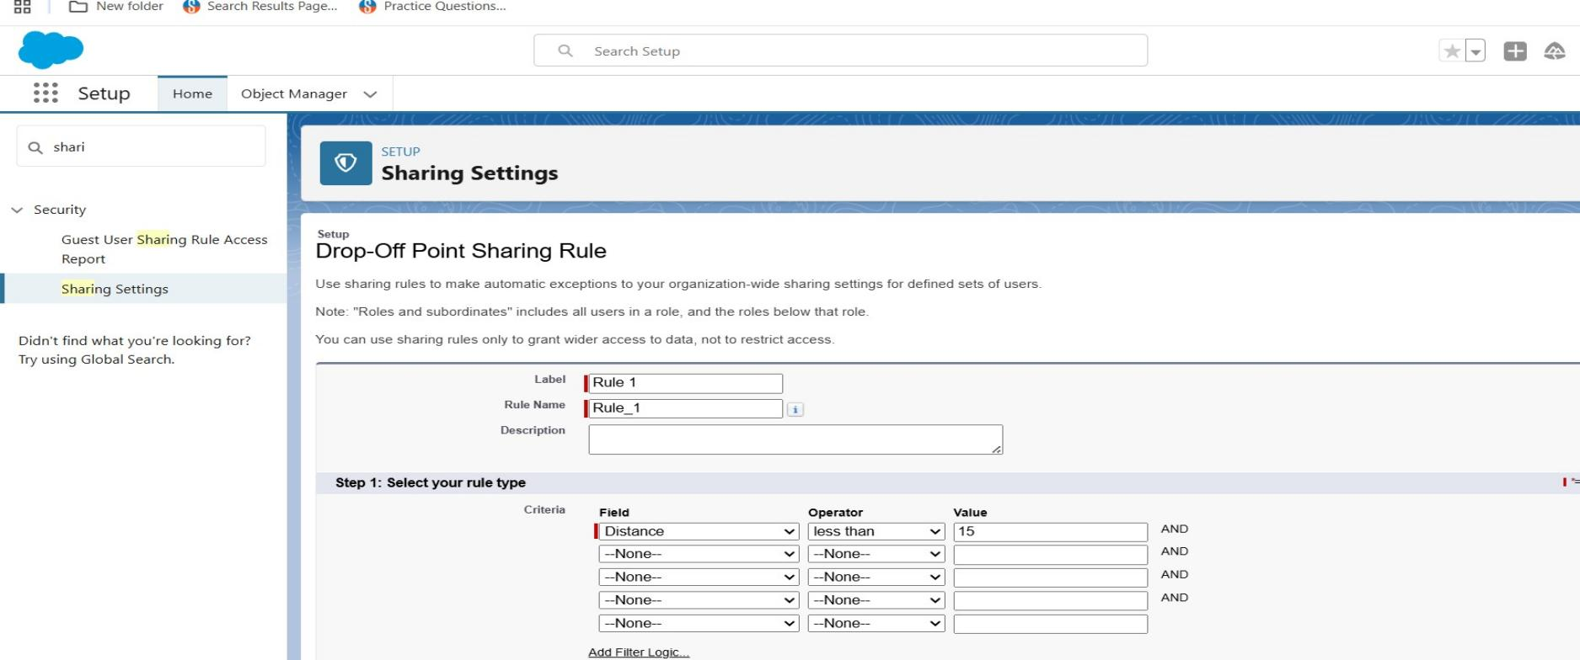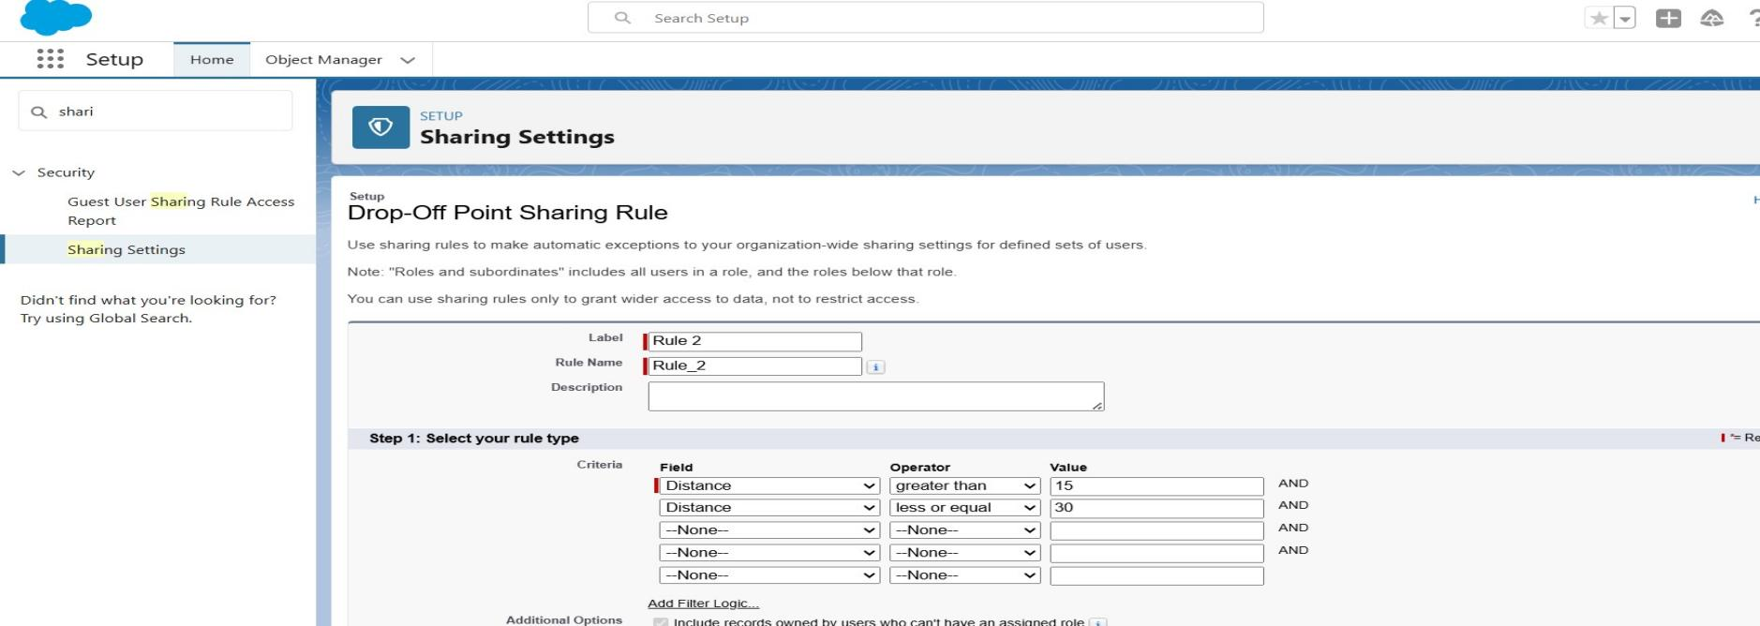Creation of sharing rules 1,2 &3 :

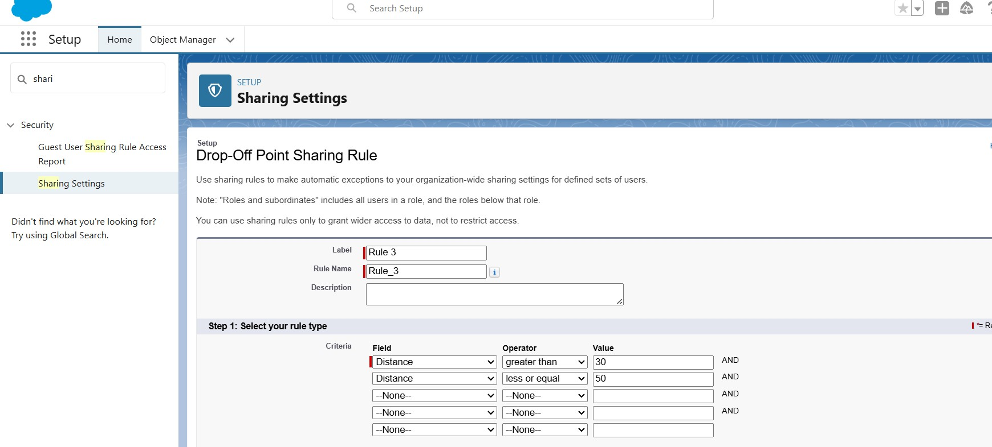

* Home page :

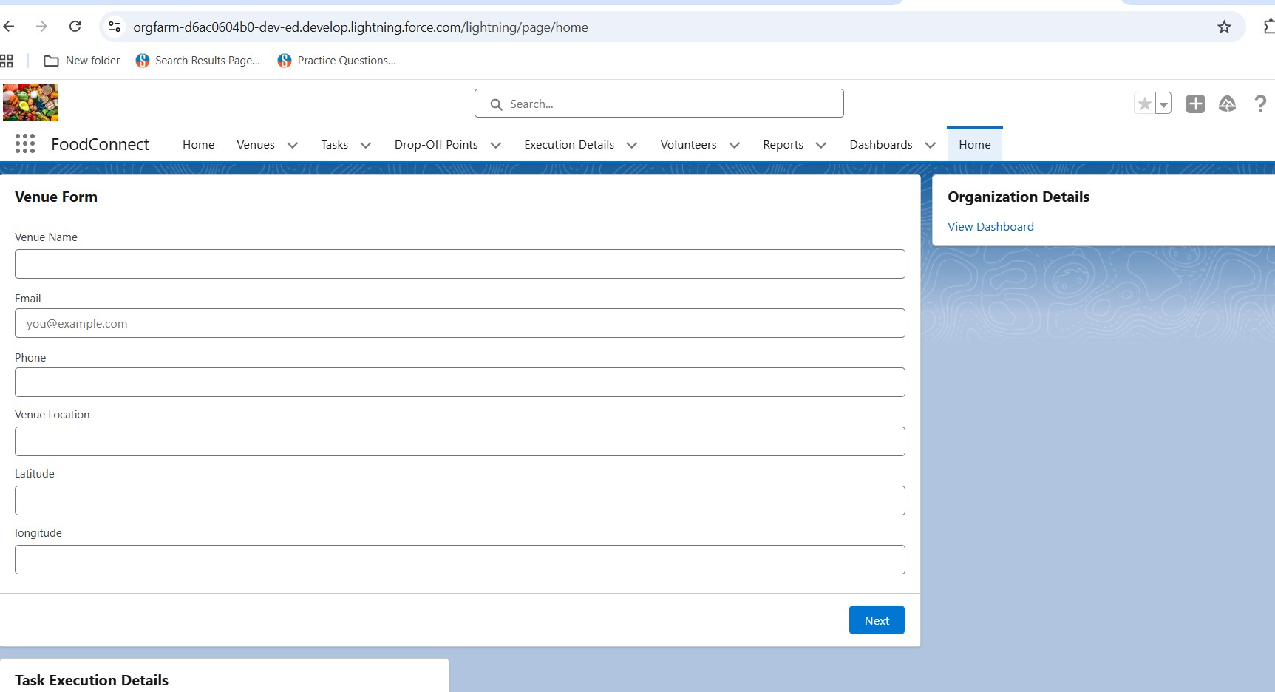

# Conclusion :

Supplying leftover food to the poor reduces both hunger and food wastage . It creates a bridge between surplus food sources and needy people . The project encourages social responsibility and awareness in the community . This initiative can bring a positive impact towards a hunger free society.

Apex trigger coding for to supply left over food to poor :

trigger Drop Off Trigger on Drop _ Off _point c (before insert) { for(Drop _ Off_ point c Drop : Trigger . new){

Drop . Distance c = Drop . distance_ calculation c;

}

}